Question 1 What is a variable in Python?

- A reserved word
- A data type
- A location in memory to store data
- A function
ANS - C

Question 2 How do you declare a variable in Python?


- var x
- x = variable
- declare x
- x = 4
ANS -D

Question 3 What is the correct way to comment a single line in Python?

- // This is a comment
- # This is a comment
- /* This is a comment */
- -- This is a comment
ANS- B

Question 4 Which of the following is a valid variable name in Python?

- 1variable
- my_variable
- global
- variable-1
ANS -B

Question 5 How do you swap the values of two variables in Python without using a third variable?

- x = y; y = x
- x, y = y, x
- temp = x; x = y; y = temp
- x + y; y = x; x = y
ANS - B

Question 6 Which of the following data types is immutable in Python?

- List
- Tuple
- Set
- Dictionary
Ans- B
Question 7 What is the output of the following code? x = 10
y = 5
z = x + y print(z)
Ans - B

- 10
- 15
- "10+5"
- Error

KODI PRAKASH SENAPATI 1

Question 8 What does the type() function return in Python?

- The value of the variable
- The type of the variable
- The memory address of the variable
- The length of the variable
ANS - B

Question 9 What is the scope of a global variable in Python?

- Limited to the function it is defined in
- Limited to the module it is defined in
- Limited to the class it is defined in
- Limited to the block it is defined in
ANS - 9

Question 10 How do you convert a string to an integer in Python?

- int(string)
- convert(int, string)
- str_to_int(string)
- stringToInt(string)
ANS - A

Question 11
What is the correct way to check if a variable is of a specific type in Python?

- type(var) == "int"
- var.type() == "int"
- isinstance(var, int)
- var.isint()
ANS - A

Question 12
What is the output of the following code?

x = 5
y = 2 print(x // y)

- 2.5
- 2
- 2.0
- 3
ANS -B

Question 13
How do you concatenate two strings in Python?

- str1 . str2
- str1 + str2
- str1 , str2
- concat(str1, str2)
ANS - B

Question 14
What is the output of the following code?

x = "Hello" print(x[1:4])

- "Hell"
- "ello"

KODI PRAKASH SENAPATI 2

- "ell"
- Error
ANS - C

Question 15
What is the purpose of the max() function in Python?

- To find the maximum value in a list
- To get the maximum length of a string
- To compare two variables
- To find the maximum of two numbers
Ans - A

Question 16
How do you find the length of a list in Python?

- len(list)
- length(list)
- list.length()
- count(list)
ANS- A

Question 17
How do you check if a key is present in a dictionary?

- key in dictionary
- key.exists(dictionary)
- dictionary.contains(key)
- has_key(key, dictionary)
ANS-A

Question 18
What is the purpose of the enumerate() function in Python?

- To get the index and value of each item in an iterable
- To count the occurrences of an element in an iterable
- To enumerate through a list
- To enumerate through a dictionary
Ans- A

Question 19
What is the output of the following code?

x = [1, 2, 3, 4]
y = filter(lambda a: a % 2 == 0, x) print(list(y))

- [1, 3]
- [2, 4]
- [1, 2, 3, 4]
- []
Ans - B

Question 20
How do you convert a list of strings to a single string in Python?

- "".join(list)
- str(list)
- convert(list, str)
- " ".join(list)
Ans - A

Question 21
How do you find the length of a list in Python?

KODI PRAKASH SENAPATI 3

- len(list)
- length(list)
- list.length()
- count(list)
Ans - A

Question 22
How do you convert a floating-point number to an integer in Python?
- int(number)
- float_to_int(number)
- number.int()
- convert(int, number)
ANS-B

Question 23
How do you create a multiline string in Python?
- "This is a multiline string"
- 'This is a multiline string'
- """This is a multiline string"""
- (a and b)
ANS-C

Question 24
How do you create a dictionary using a comprehension in Python?

- {key: value for key, value in iterable}
- dict(iterable)
- create_dict(iterable)
- {key, value in iterable}
ANS- A

Question 25
What is the purpose of the dict attribute in Python?
- To access the dictionary of a list
- To access the dictionary of a class or module
- To define a dictionary in Python
- To convert a dictionary to a list
ANS -B

Question 26
Which of the following cannot be a Python variable name?
- Int_1
- true
- var-2
- name3
Ans -C

Question 27
Which of the following is not a Python Data Type?
- int
- string
- char
- set
ANS - C

Question 28
What is the output of the following code? python
KODI PRAKASH SENAPATI 4

Copy code print(type({}))

- <class 'set'>
- <class 'list'>
- <class 'tuple'>
- <class 'dict'>
ANS -D

Question 29
Which data type can be used to store the percentage obtained by a student?

- Boolean
- Float
- String
- Integer
ANS-B

Question 30
dic = {1: 'A', 2: 'E', 3: 'I'}
dic[4] = 'O'print(dic)
- {1: 'A', 2: 'E', 3: 'I', 4: 'O'}
- {1: 'A', 2: 'E', 4: 'O'}
- {4: 'O', 1: 'A', 2: 'E'}
- Error
ANS-A

Question 31
What is the output of the following code?

list1 = ['a', 'b', 'g', 1, 5] print(list1.pop)
- 5
- ['a', 'b', 'g', 1]
- ['b', 'g', 1, 5]
- Syntax error
ANS- D

Question 32
Which of the following operators is used to add elements at the end of a list?
- add()
- join()
- attach()
- append()
ANS - D

Question 33
var = 2
print(2 == 2.0)
- true
- False
- True
- false
Ans- A

Question 34
KODI PRAKASH SENAPATI 5

num = 4 + 0j print(type(num))
- int
- float
- complex
- real
ANS - D
Question
print(int(3.9))
- 4
- 3.9
- 3
- None
ANS-3

Question 36
a = 'Python' + ".py" print(a)
- Python.py
- Python .py
- Python +.py
- Error
ANS -A

Question 37
In which of the following is indexing not allowed?

- Dictionary
- Set
- Tuple
- None
Ans - B

Question 38
What is the output of the following code?

print(str(True), end=" ")
int("4.5")

- True SyntaxError
- 'True' ValueError
- True 4
- SyntaxError SyntaxError
Ans- B

Question 39
Which of the following gives the output as “ello” from name = "Hello, World!"?
- print(name[1:5])
- print(name[1:4])
- print(name[2:5])
- print(name[2:6])
ANS - A

Question 40

KODI PRAKASH SENAPATI 6

set1 = {1, 5, 6, 4, 3}
print(set1)
- {1, 3, 4, 5, 6}
- {1, 5, 6, 4, 3}
- 1, 5, 6, 4, 3
- (1, 5, 6, 4, 3)
ANS- A
Question 41
What is the output of the following code?
x = 50
def fun1(): x = 25
print(x)

fun1() print(x)
- NameError
- 25
25
- 25
50
ANS -C

Question 42
What is the output of the following variable assignment?

x = 75
def myfunc(): x = x + 1 print(x)

myfunc() print(x)
- Error
- 76
- 1
- None
ANS - A

Question 43
What is the data type of print(type(0xFF))?

- number
- hexint
- hex
- int
Ans- int

Question 44
Select all the right ways to create a string literal Ault'Kelly

- str1 = 'Ault\\'Kelly'
- str1 = 'Ault\'Kelly'
- str1 = """Ault'Kelly"""
Ans- B,C

Question 45
What is the data type of the following?
KODI PRAKASH SENAPATI 7

aTuple = (1, 'Jhon', 1+3j) print(type(aTuple[2:3]))
- list
- complex
- tuple
- str
Ans - tuple

Question 46
What is the output of the following code?
print(bool(0), bool(3.14159), bool(-3), bool(1.0+1j))

- False True False True
- True True False True
- True True False True
- False True True True
Ans- D

Question 47
What is the output of the following code?

def func1(): x = 50
return x func1() print(x)

- 50
- NameError
- None
- 0
Ans - B

Question 48
What is the output of print(type({}) is set?
- True
- False
Ans- 48

Question 49
Please select the correct expression to reassign a global variable x to 20 inside a function fun1():
x = 50
def fun1():
# your code to assign global x = 20 fun1()
print(x) # it should print 20
- Global x = 50
- global var x X = 20
- global.x = 20
- global x x = 20

Question 50
Select all the valid string creation in Python:

KODI PRAKASH SENAPATI 8

- str1 = 'str1'
- str1 = "str1"
- str1 = '''str'''
- str1 = 'str1'
Ans- ABC

Question 51
In Python 3, what is the output of type(range(5))? (What data type will it return).

- int
- list
- range
- None
Ans - C
Question 52
What is the data type of print(type(10))?

- float
- integer
- int
- None
Ans - C
Q53. What is the data type of the variable “x” in the following code snippet? x = 5
  - Integer
  - String
  - Float
  - Boolean
Ans - A
Q54. What will be the output of the following code snippet?
x = "Hello"
print(type(x))
ANS - B
- hello
- str
- string
- String

Q55. Which data type in Python is used to store a sequence of characters?
- Integer
- Float
- String ANS - c

- Boolean
Q56. What is the output of the following code snippet? x = 3.14
print(type(x))
  - int
  - Integer
  - float
  - Float
Ans- C

KODI PRAKASH SENAPATI
9

Q57. Which data type is used to store a collection of items, where each item is indexed by a key?
- List
- Tuple
- Set
- Dictionary
Ans - D
Q58. What will be the output of the following code snippet?
x = 10
y = "20"

print(x + int(y))

- 30
- 1020
- “1020”
- Error
Ans -A
Q59. Which data type in Python is mutable?
- String
- Tuple
- Set
- List Ans - D
Q60. What will be the output of the following code snippet? x = {"apple", "banana", "cherry"}
print(type(x))

- set
- Set
- list
- List
Ans - A
Q61. Which data type is used to store a collection of items, where each item is unique and unordered?
- List
- Tuple
- Set
- Dictionary ANS- C
Q62. What is the output of the following code snippet? x = {"name": "John", "age": 30}
print(type(x))
- dictionary
- dict
- Dictionary
- Dict ANS - b
Q63. What is the data type of the variable “x” in the following code snippet? python
Copy code
x = True

KODI PRAKASH SENAPATI 1
0

- Integer
- String
- Float
- Boolean Ans = d
Q64. What will be the output of the following code snippet? x = [1, 2, 3]
print(type(x))
- list
- List
- Array
- Array
ANS -a
Q65. Which data type is used to store a collection of items, where each item is indexed by a numerical index?
- List
- Tuple
- Set
- Dictionary
Ans - a
Q66. Which of the following statements about Python strings is true?
- Strings in Python are mutable.
- Strings can only contain numeric characters.
- Strings can be concatenated using the “+” operator.
- Strings can be accessed by numerical indices.
Ans -C
Q67. Which data type in Python is immutable?
- List
- Tuple
- Set
- Dictionary Ans - B
Q68. What will be the output of the following code snippet? x = 10
y = "20"
print(str(x) + y)

- 30
- “1020”
- Error
- “10200” Ans - b
Q69. What is the output of the following code snippet? x = [1, 2, 3]
y = x.copy()
- append(4) print(y)

  - [1, 2, 3]
  - [1, 2, 3, 4]
  - [1, 2, 3, 4, 4]
  - [1, 2, 3, 3]
Ans - a
KODI PRAKASH SENAPATI 1
1

Q70. What will be the output of the following code snippet?

x = {"a", "b", "c"}
y = {"b", "c", "d"}
z = x & y print(z)
- {“a”, “b”, “c”, “d”}
- {“b”, “c”}
- {“a”, “d”}
- {“a”, “b”, “c”}Ans - b
Q71. What is the output of the following code snippet? x = 10
y = 20
x, y = y, x print(x, y)

- 10 20
- 20 10
- 20 20
- 10 10 Ans - b
Q72. What will be the output of the following code snippet? x = {"a": 1, "b": 2}
y = {"b": 3, "c": 4}
z = {**x, **y} print(z)

- {“a”: 1, “b”: 3, “c”: 4}
- {“a”: 1, “b”: 2, “c”: 4}
- {“b”: 3, “c”: 4}
- {“a”: 1, “b”: 2}Ans - a

Q73. Which data type in Python represents a sequence of characters?
- Integer
- Float
- String
- Boolean Ans - c
Q74. What will be the output of the following code snippet? x = {1, 2, 3}
- clear() print(x)
  - {}
  - {1, 2, 3}
  - None
  - Error Ans - a

Q75. Which data type in Python is used to represent a true or false value?
- Integer
- String

KODI PRAKASH SENAPATI 1
2

- Float
- Boolean Ans - d
Q76. What will be the output of the following code snippet? x = "hello"
y = x.upper()
print(y)

- hello
- Hello
- HELLO
- hELLO
Ans - C
Q77. Which data type in Python is used to store a collection of items, where each item is indexed by a key?
- List
- Tuple
- Set
- Dictionary Ans - d
Q78. What is the output of the following code snippet? x = "hello"
y = x.replace("l", "L", 1) print(y)

- hello
- helLo
- heLLo
- heLo Ans- heLlo
Q79. What is the output of the following code snippet?
x = (1, 2, [3, 4])
x[2][0] = 5
print(x)

- (1, 2, [3, 4])
- (1, 2, [5, 4])
- (1, 2, [3, 5])
- Error Ans - b
Q80. What will be the output of the following code snippet? x = {"name": "John", "age": 30}
print(x["address"])

- “John”
- 30
- None
- Error
Ans - D
Q81. Which data type in Python is used to store a collection of items, where each item is unique and unordered?
- List

KODI PRAKASH SENAPATI 1
3

- Tuple
- Set
- Dictionary Ans - C
Q82. What is the output of the following code snippet? x = [1, 2, 3]
y = x[:] x[0] = 4
print(y)

- [1, 2, 3]
- [4, 2, 3]
- [1, 2, 3, 4]
- [4, 2, 3, 4] Ans - A
Q83. What is the output of the following code snippet? x = {“name”: “John”, “age”: 30}
y = x.copy()
x[“name”] = “Jane”
print(y[“name”])

- “John”
- “Jane”
- 30
- Error Ans - a
Q84. What will be the output of the following code snippet? x = {"apple", "banana", "cherry"}
y = x.pop()
print(y)

- “apple”
- “banana”
- “cherry”
- Error Ans - b

Q85. Which data type in Python is used to store a collection of items, where each item is indexed by a numerical index?
- List
- Tuple
- Set
- Dictionary Ans = a
Q86. What is the output of the following code snippet? x = [1, 2, 3]
x.insert(1, 4) print(x)
- [1, 4, 2, 3]
- [4, 1, 2, 3]
- [1, 2, 4, 3]
- [1, 2, 3, 4]
Ans - a
KODI PRAKASH SENAPATI 1
4

Q87. What will be the output of the following code snippet?

x = {"a", "b", "c"}
y = x - {"b"} print(y)

- {“a”, “b”, “c”}
- {“a”, “c”}
- {“b”, “c”}
- Error Ans - b
Q88. What is the output of the following code snippet? x = {1, 2, 3}
y = x.add(4) print(x)

- {1, 2, 3, 4}
- {1, 2, 3}
- {1, 2, 3, None}
- Error Ans – a # set.add() changes the set directly and doesn’t return the new set.
Q89. What is the data type of the variable “x” in the following code snippet? x = [1, 2, 3]
- List
- Tuple
- Set
- Dictionary Ans = a

Q90. Which data type in Python is used to store a sequence of items, where each item is ordered and can be changed?
- List
- Tuple
- Set
- Dictionary Ans - a

str1 = "str1"" str1 = '''str1''
- str1 = str(Jessa)

Q 91

KODI PRAKASH SENAPATI 1
5

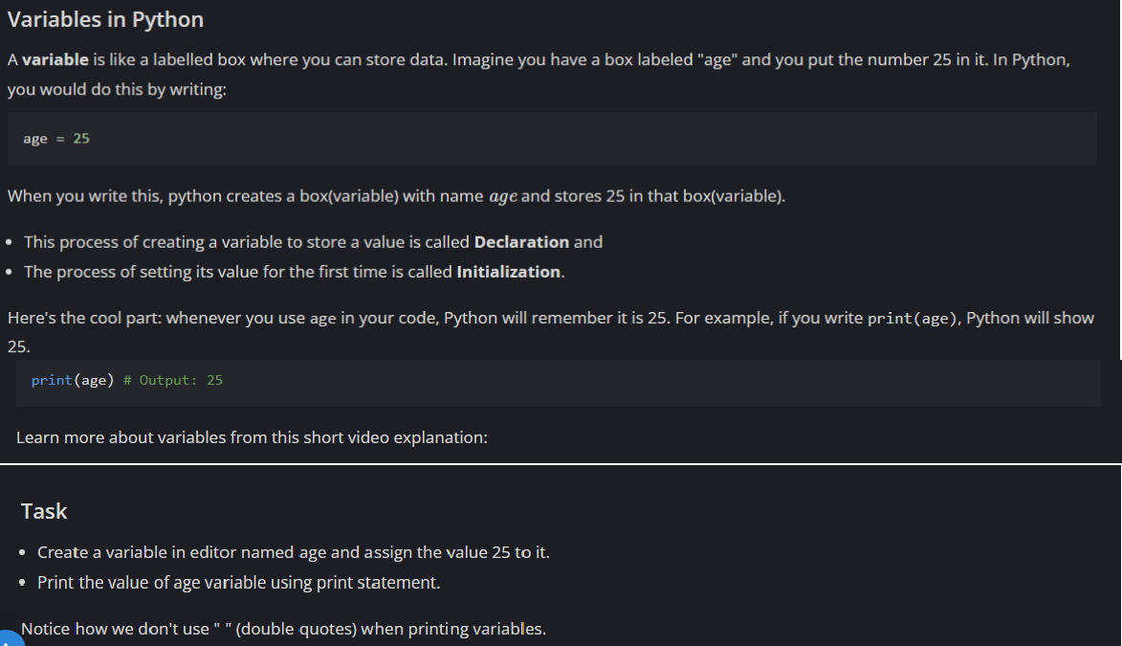
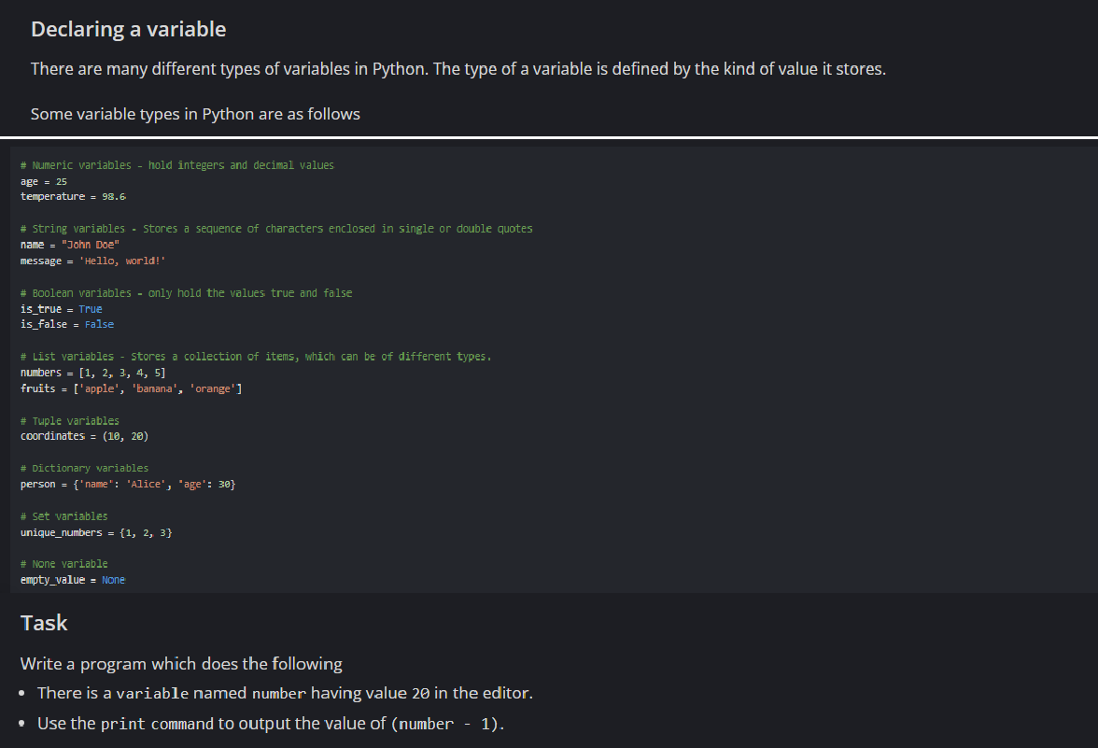
Q 92.

Q 93.

KODI PRAKASH SENAPATI 1
6

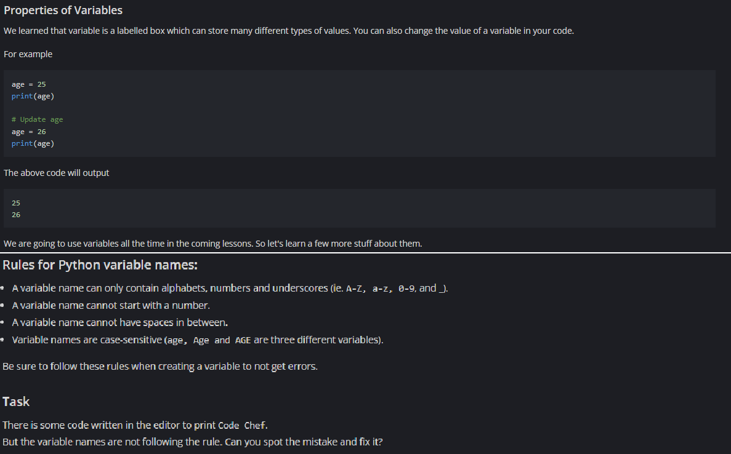
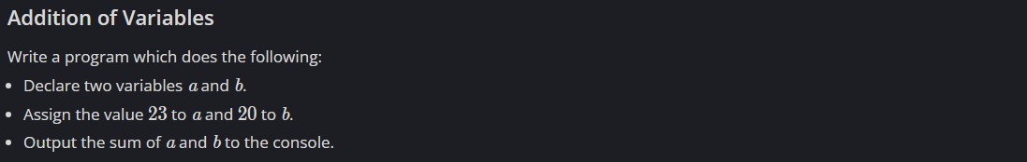
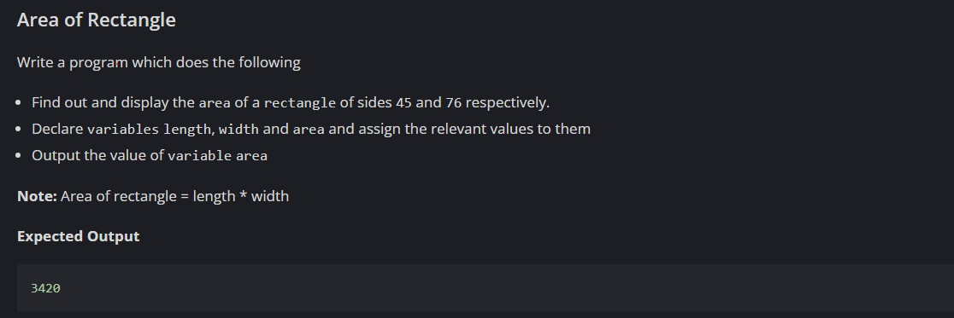
Q 94.

Q 95.

KODI PRAKASH SENAPATI 1
7

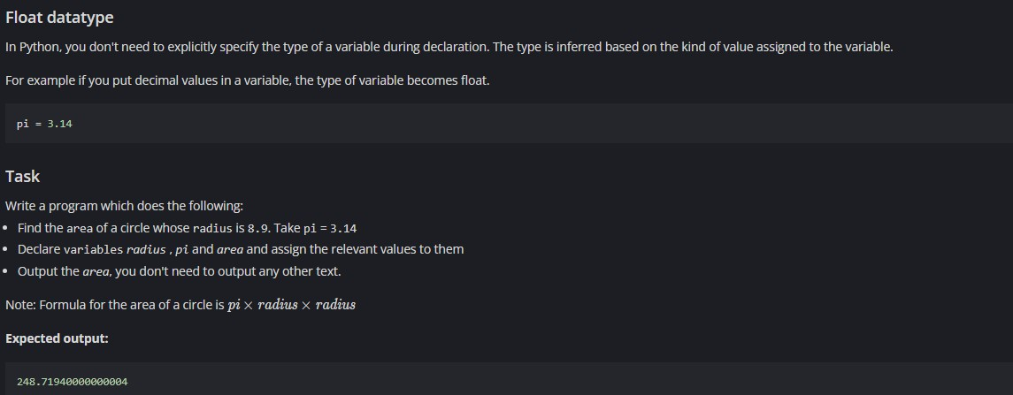
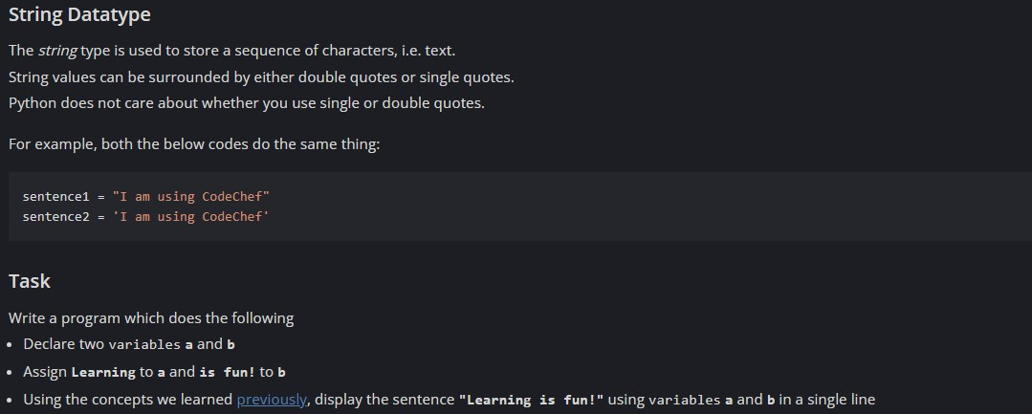
Q 96.

Q 97.

KODI PRAKASH SENAPATI 1
8

